AWS IOTs MQTT test Client to See Data Received from AWS IOT Things.

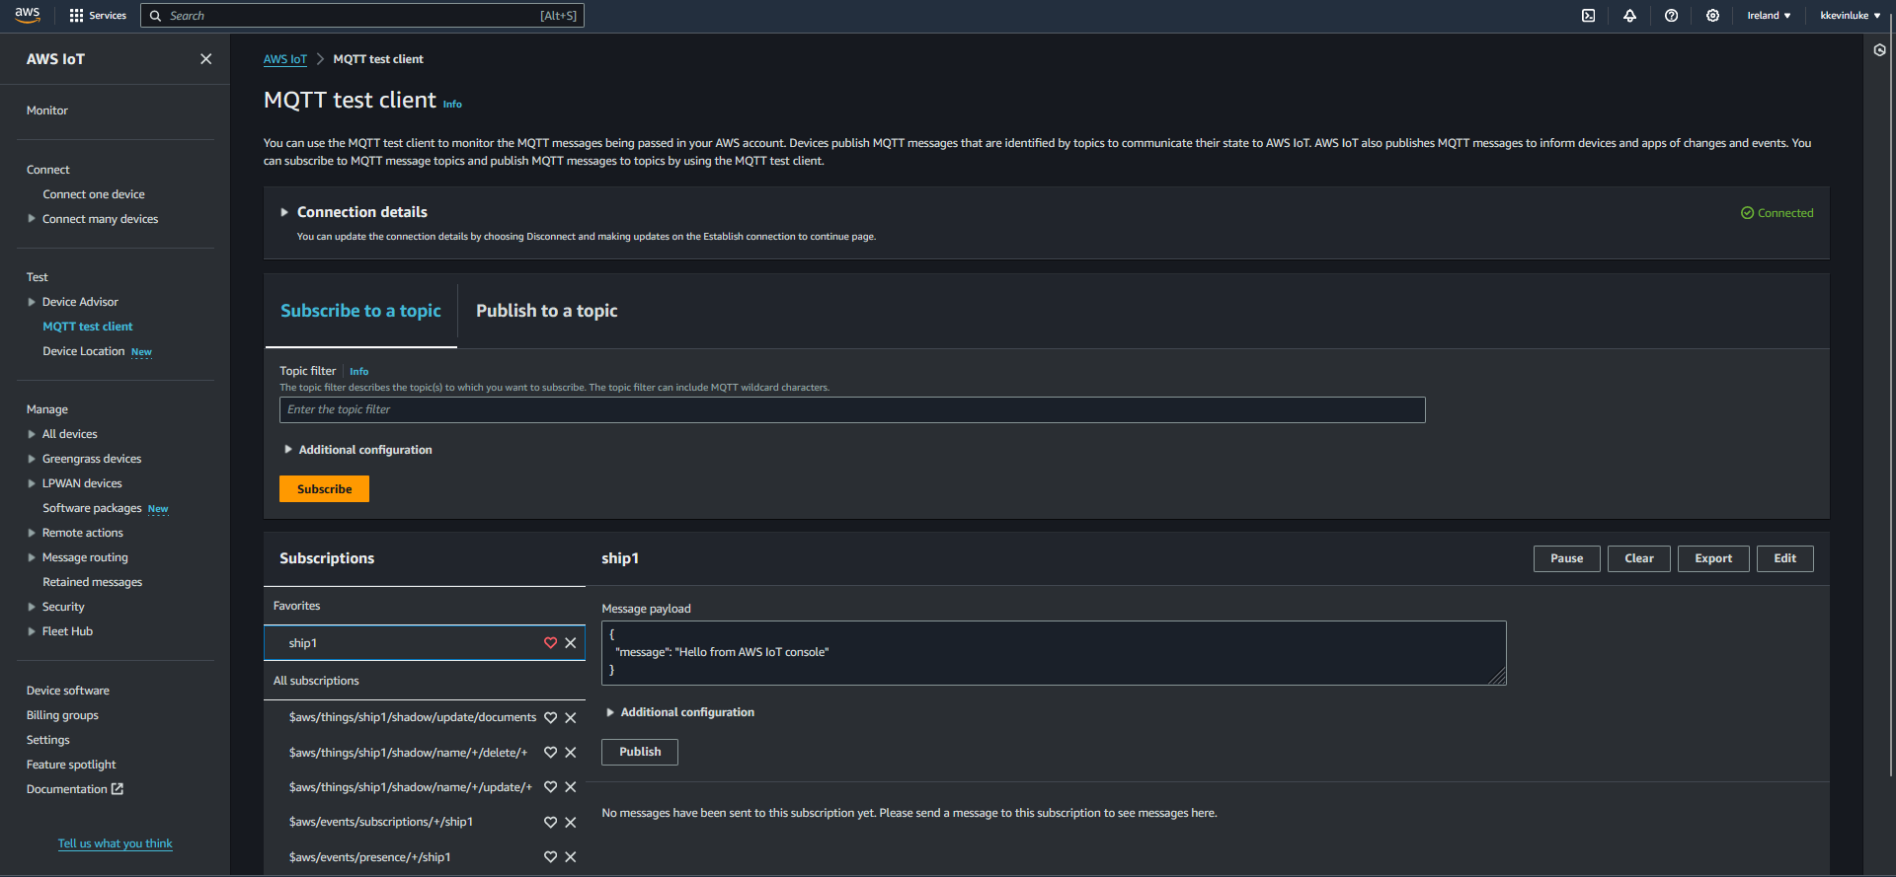

IAM User Roles that will automatically Generate.

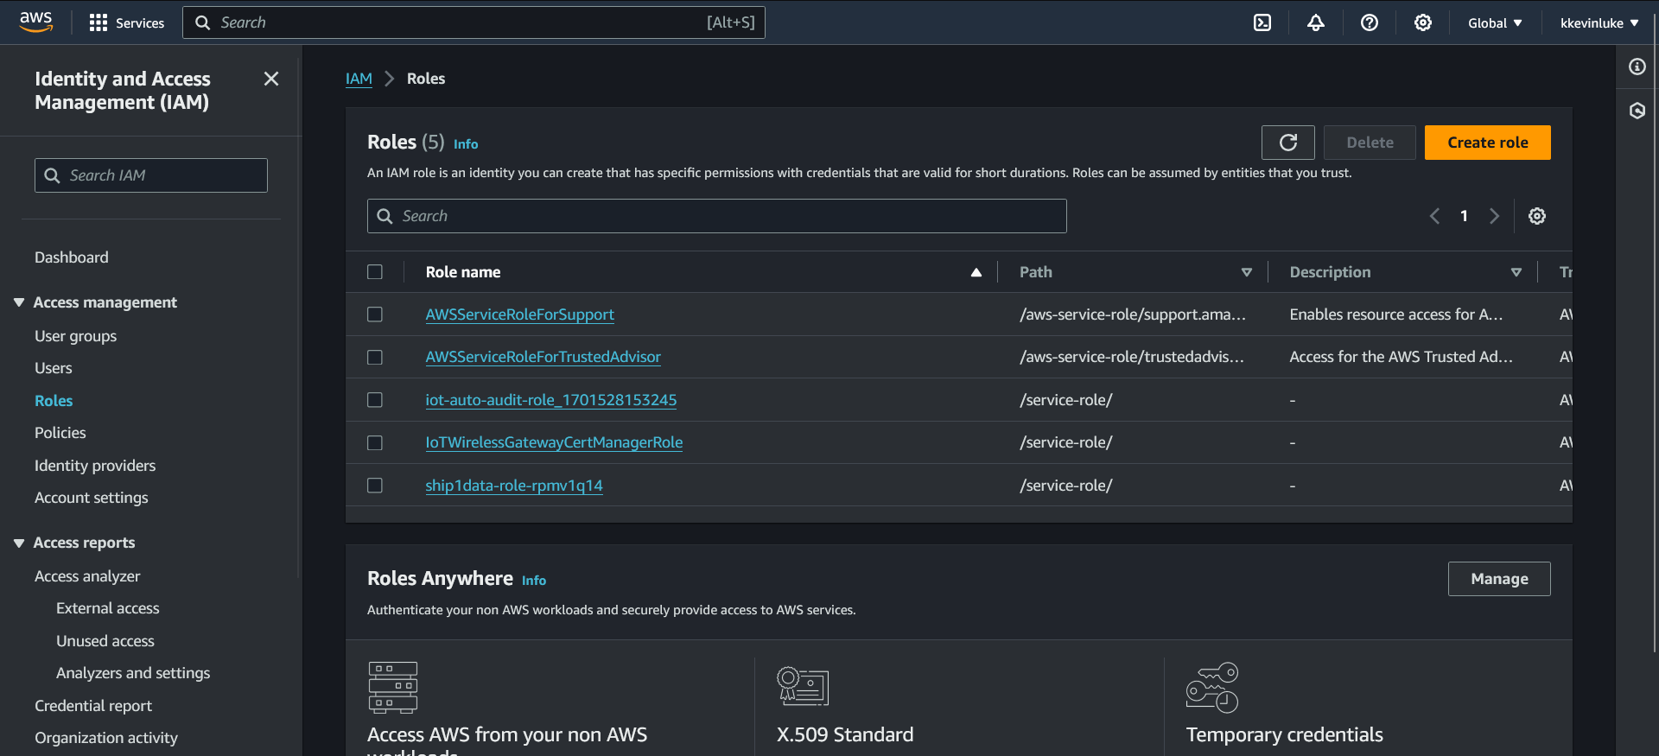

The Lambda function to take Data from AWS IOT Core to S3 Bucket

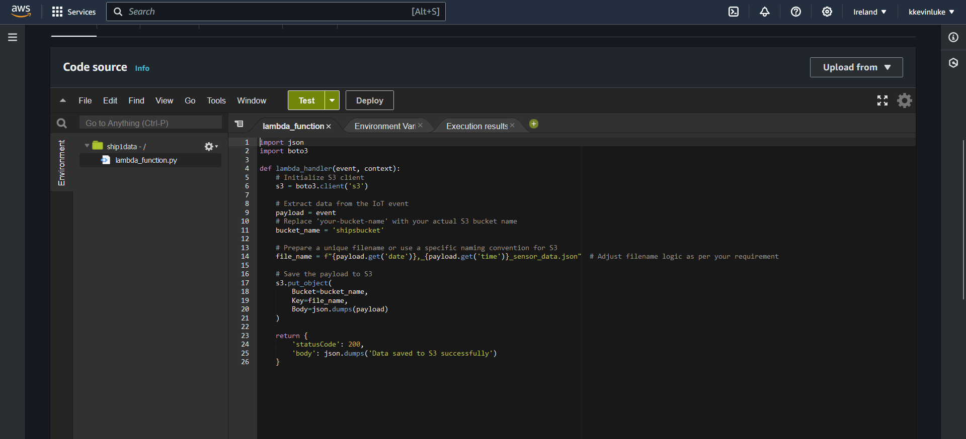

This is Trigger that exists to activate the Lambda Function, and it has a rule we created attached to it.

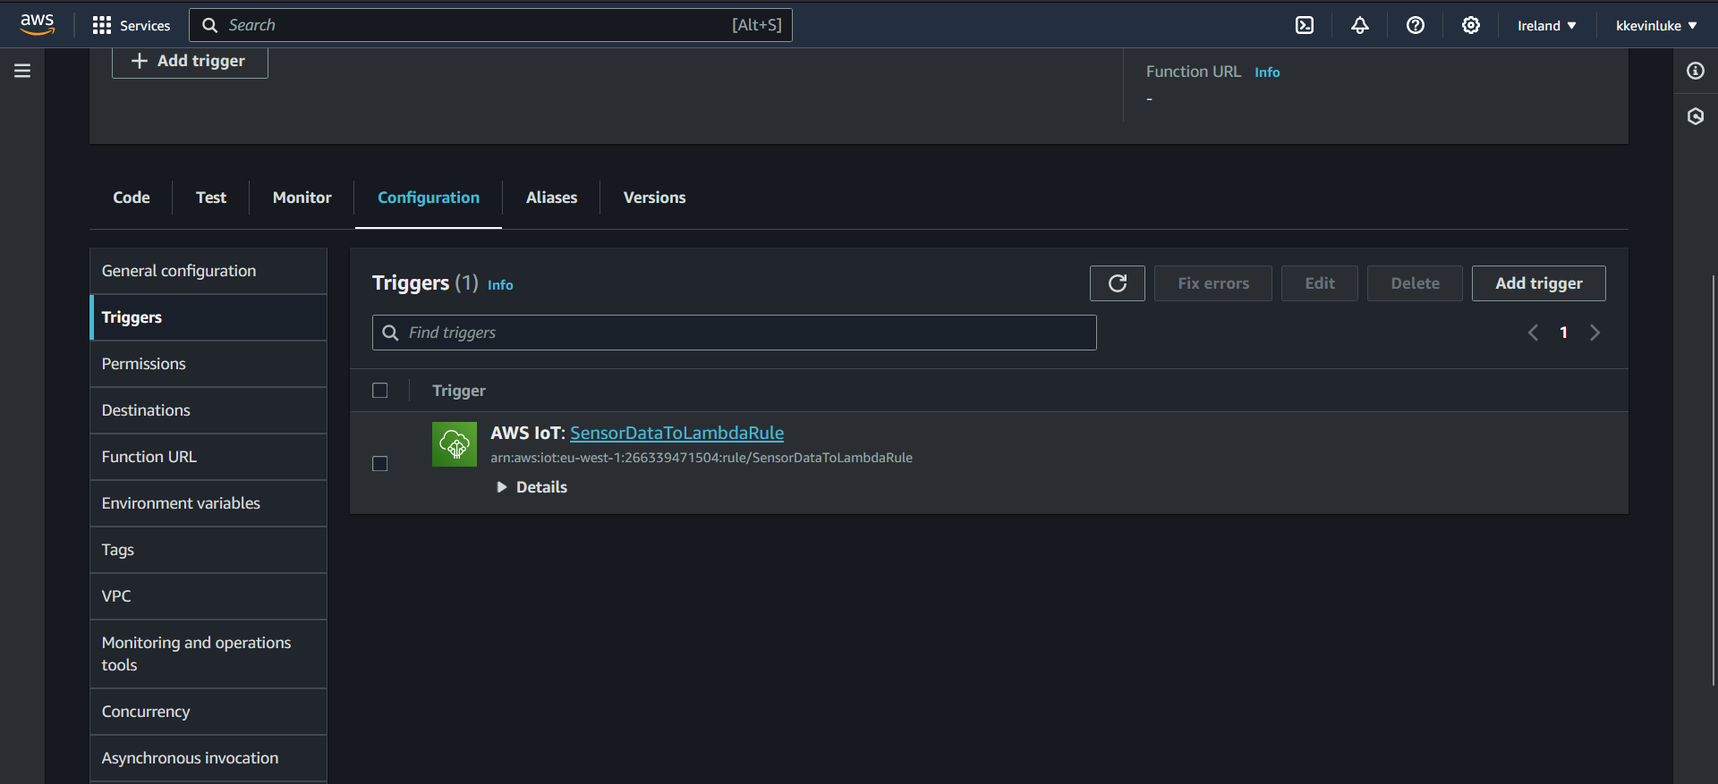

Here is what the Rule in the trigger Looks like

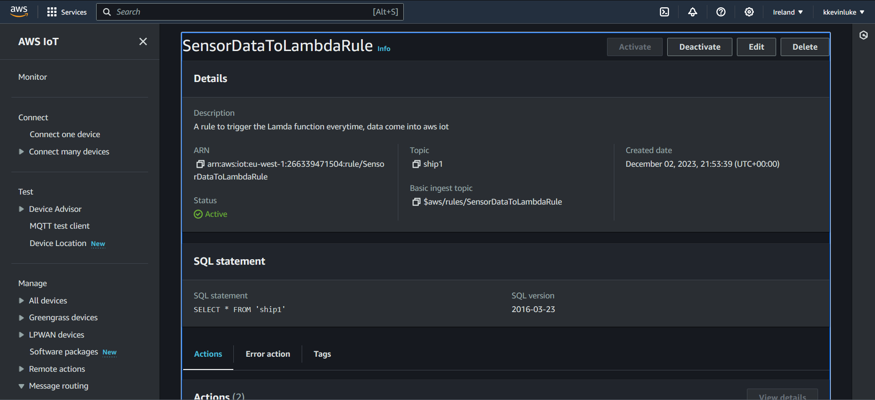

AWS Iot Core when the ship sensor Data Comes in

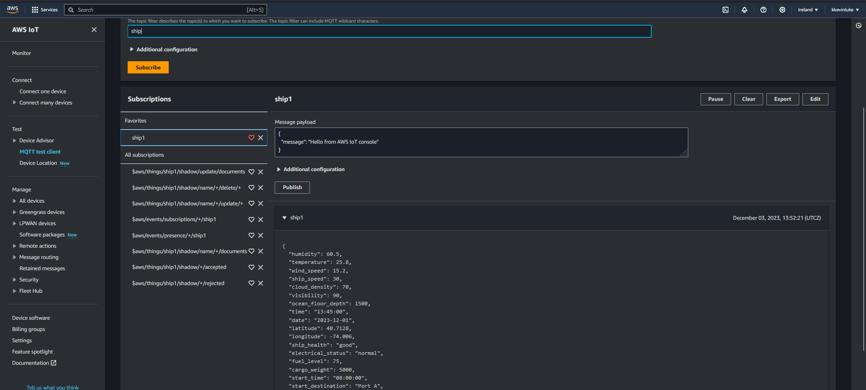

This Policy we created allows AWS IOT to do its necessary functions.

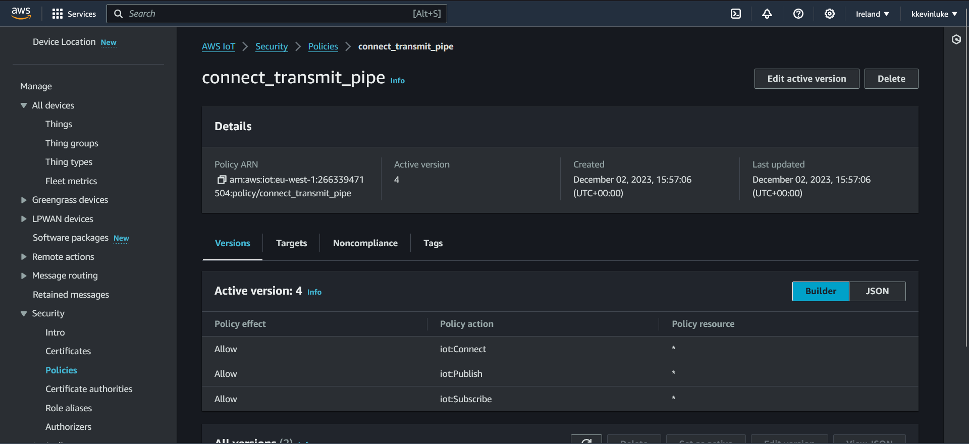

You can normally select the drop down beside actions to create policy or write a JSON file.

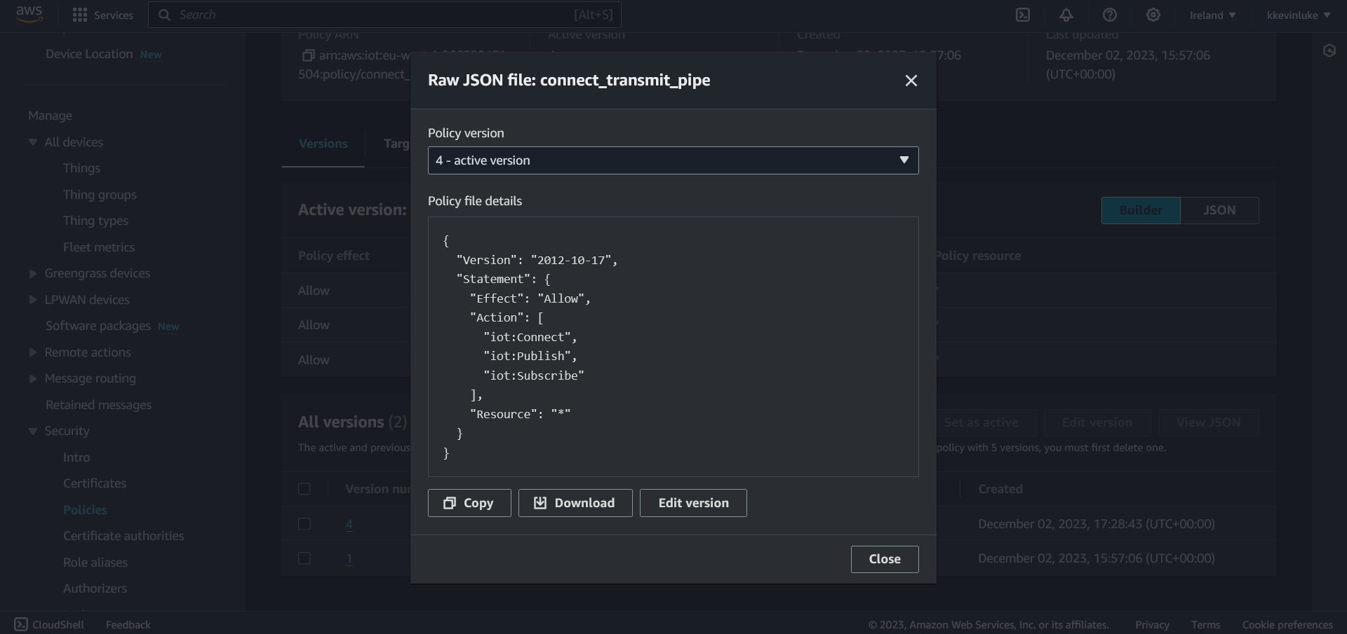

The Thing called Ship1 on AWS IOT used to Simulate sensors on a ship.

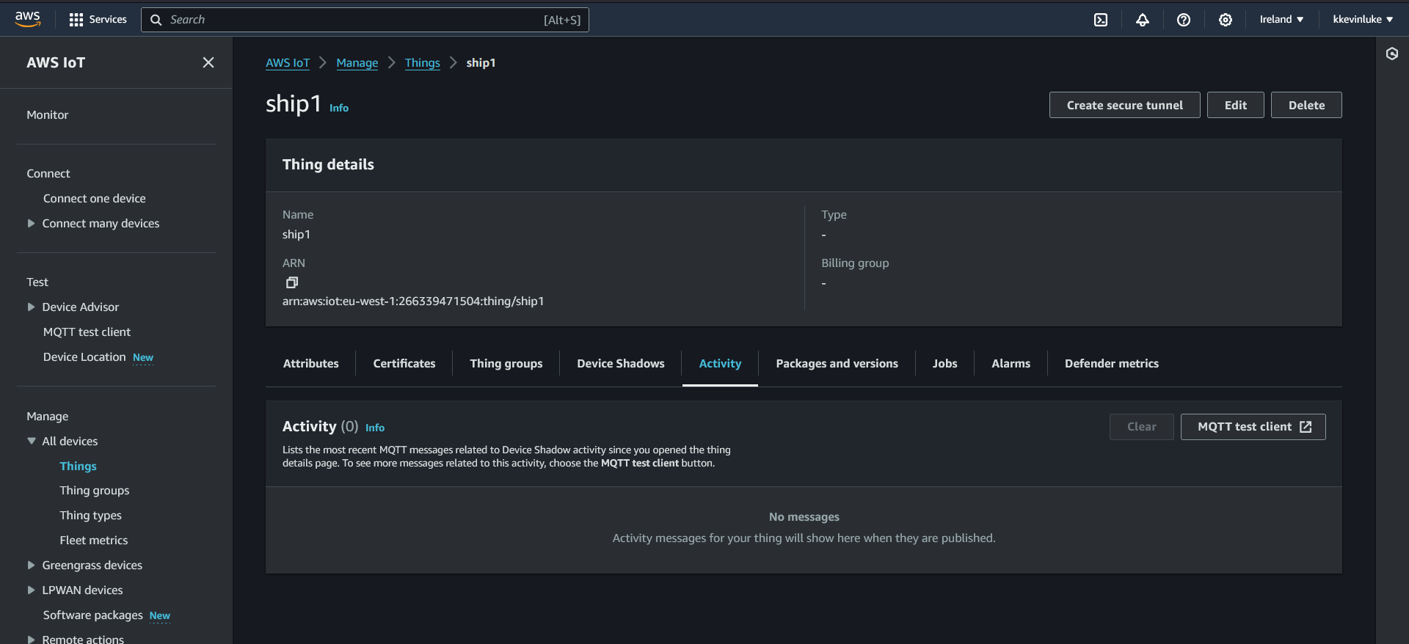

This is what the Lambda Function Looks like, and the trigger we chose was AWS iot with a rule we created, called Sensor Data to Lambda Rule.

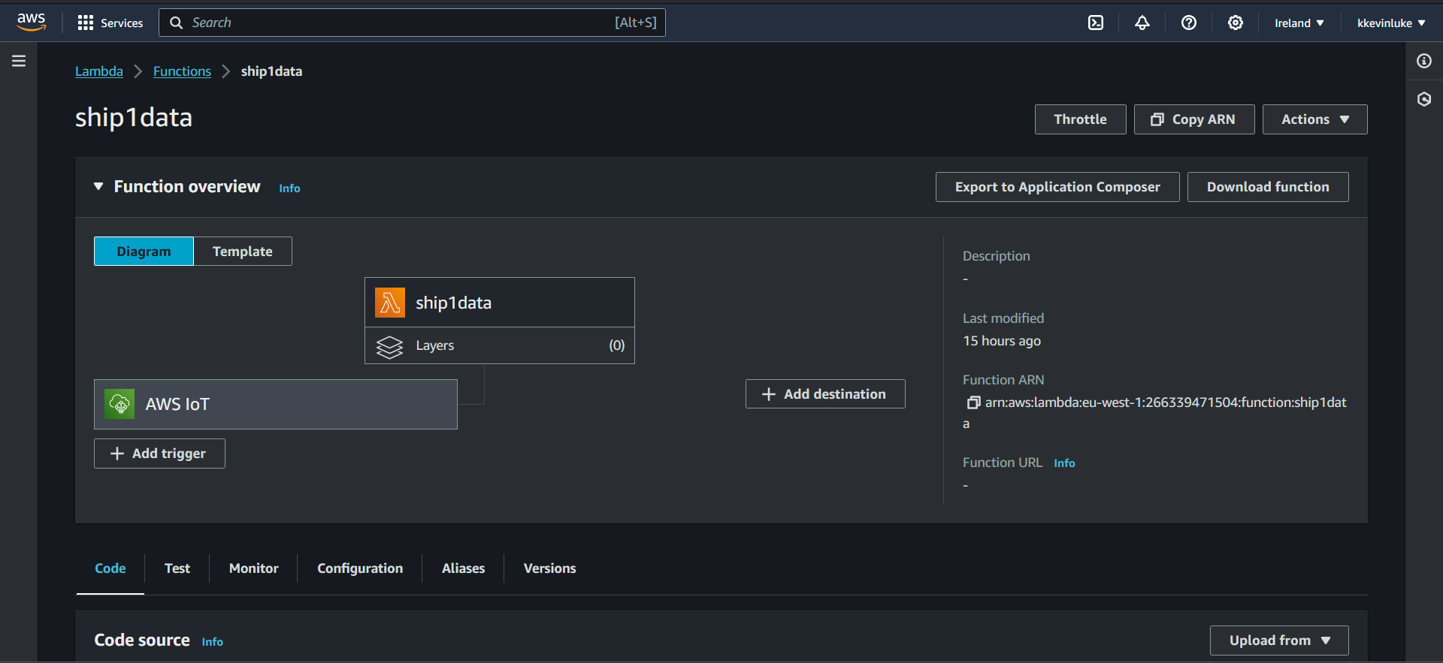

This is the S3 Bucket, showing received data from as a JSON file from the AWS IOT Core using Lambda Functions.

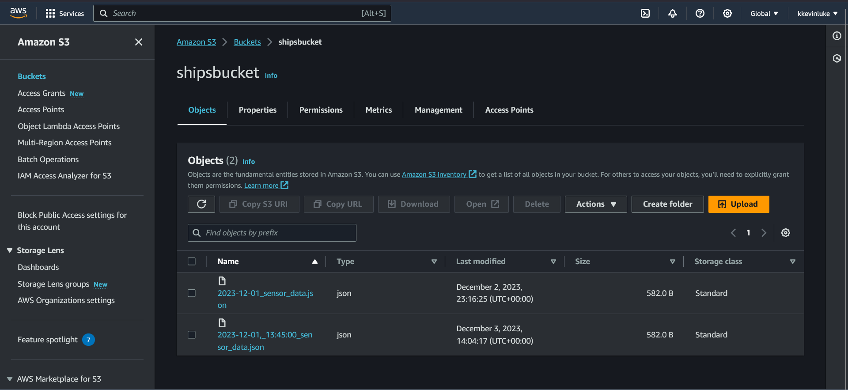

The IAM Page

